Title

Submitted in partial fulfilment of the requirements

of the degree of

Bachelor of Engineering in

Artificial Intelligence and Data Science

by

***Satyam Dubey***

***Soham Jadiye***

***Pranav Kotkar***

***Yash Pandey***

under the guidance of

Supervisor (s): **Dr. Manimala**

Name of Guide :

**Dr. M.Vijayalakshmi , Mr. Ajinkya . Valanjoo**



**Department of Artificial Intelligence and Data Science**

**Vivekanand Education Society’s Institute of Technology**

**2021-2022**

**Department of Artificial Intelligence and Data Science**

**CERTIFICATE**

This is to certify that **Mr *Satyam Dubey,Soham Jadiye,Pranav Kotkar,Yash Pandey*,** of Second Year of Artificial Intelligence and Data Science studying under the University of Mumbai have satisfactorily presented the Mini Project entitled **N-Puzzle** as a part of the MINI-PROJECT for Semester-III under the guidance of **Dr. M.Vijayalakshmi , Mr. Ajinkya . Valanjoo** in the year 2021-2022.

Date:18/12/2021

(Name and sign) (Name and sign)

Head of Department Supervisor/Guide

**Department of Artificial Intelligence and Data Science**

**DECLARATION**

We, ***Satyam Dubey,Soham Jadiye,Pranav Kotkar,Yash Pandey*** from ***D6AD***, declare that this project represents our ideas in our own words without plagiarism and wherever others' ideas or words have been included, we have adequately cited and referenced the original sources.

We also declare that we have adhered to all principles of academic honesty and integrity and have not misrepresented or fabricated or falsified any idea/data/fact/source in our project work.

We declare that we have maintained a minimum 75% attendance, as per the University of Mumbai norms.

We understand that any violation of the above will be cause for disciplinary action by the Institute.

Yours Faithfully

1.***Satyam Dubey***

2.***Soham Jadiye***

3.***Pranav Kotkar***

4. ***Yash Pandey***

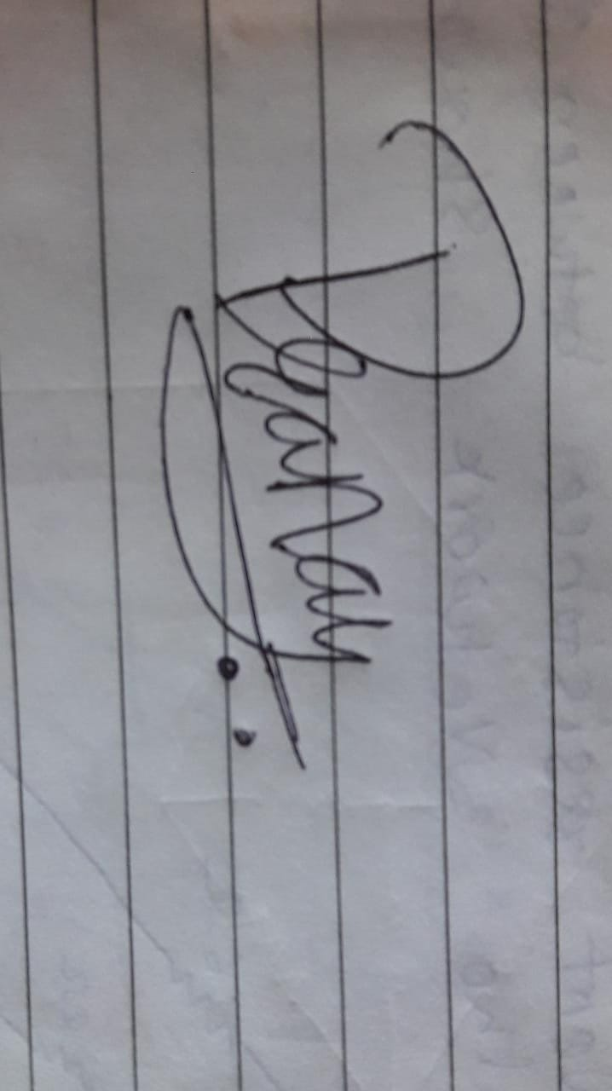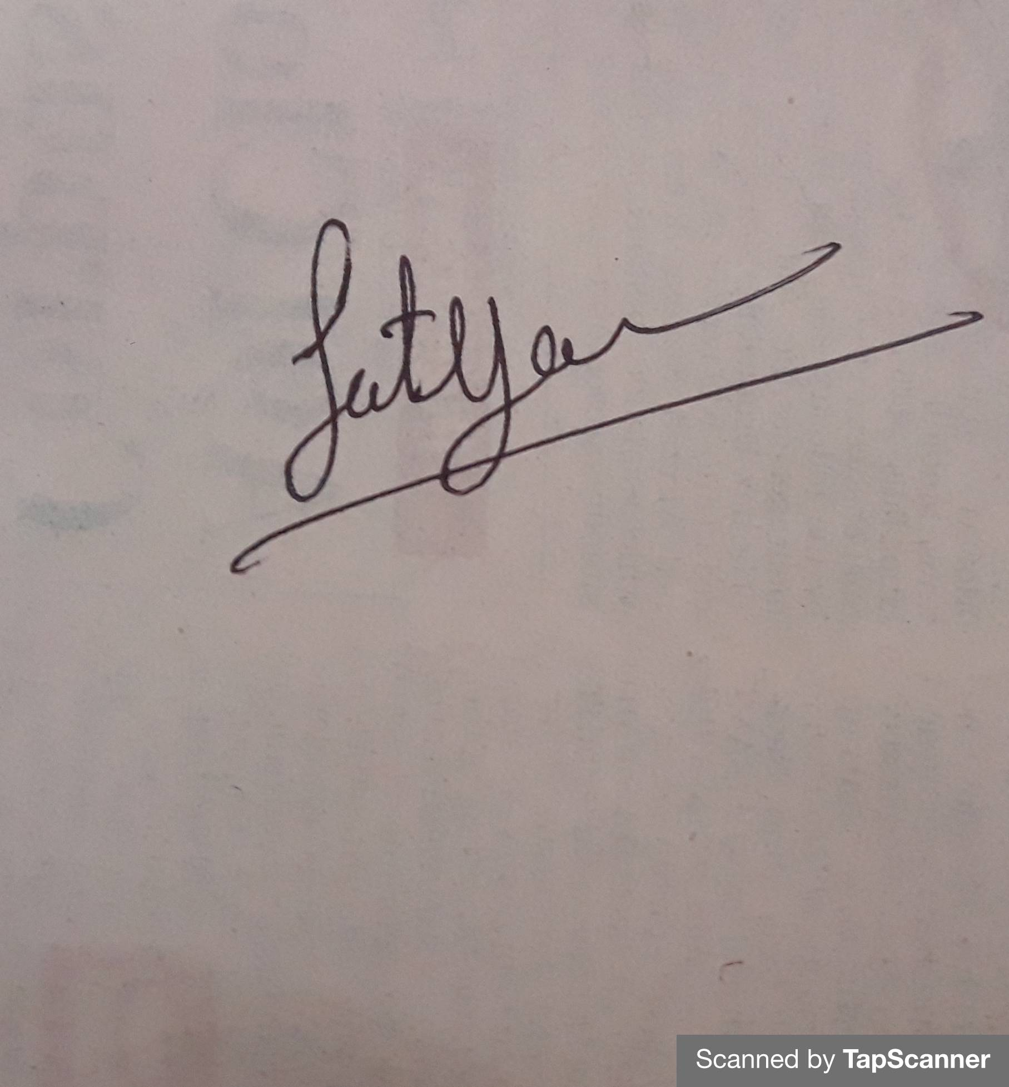

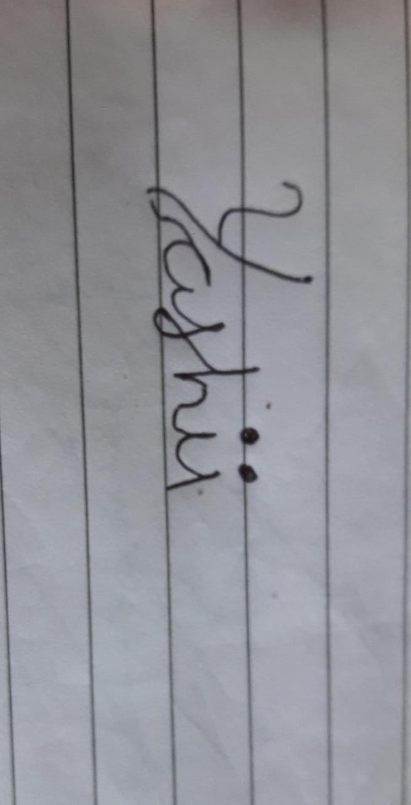 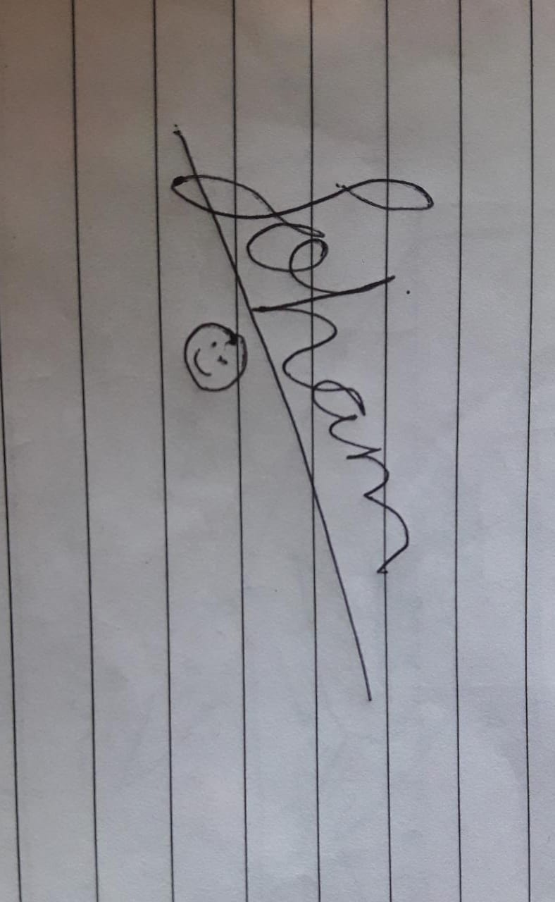

(Name & Signature of Students with Date)

**Acknowledgement**

Table of Contents

**Abstract**

**List of Tables**

**List of Figures**

**1. Introduction** Pg No

1.1. Introduction

1.2. Problem Statement

1.3. Objectives

1.4. Scope

**2. Literature Survey**

2.1 Literature/Techniques studied

2.2 Papers/Findings

**3. Analysis and Design**

3.1 Analysis of the system

3.2 Proposed Solutions

3.3 Design of the proposed system

**4. Results and Discussion**

**5. Conclusion and Future Work**

**References**

**Abstract** **:**

**8 Puzzle**

**•An 8 puzzle is simply game consisting of 3 x 3 grid (containing 8 squares).**

**•One of the squares is always empty.**

**•The objective is to move to the squares around into different positions and having the numbers displayed in the "goal state".**



**•An 15 puzzle is a simple game consisting of a 4 x 4 grid (containing 16 squares).**

**•One of the squares is always empty.**

**Introduction :**

**We are going to create a N- Puzzle game through which the user will get an opportunity to either select 8 puzzle or will get to play 15 puzzle .**

**After which the user will get an option to randomize the board and a start button will be displayed on the board which will start solving the puzzle and the intermediate steps will be displayed on the board .**

**After which the final output will appear on the screen along with the number of iteration and the depth of the solution i.e. (the leaf node).**

**Scope:**

**Will be able to show/ help the user as to which move can increase his chances to complete the task in minimal moves.**

**Literature Survey :**

**Experimental Comparison of Uninformed and Heuristic AI Algorithms for N Puzzle and 8 Queen Puzzle Solution.(Written by Kuruvilla Mathew and Mujahid Tabassum)**

**https://www.researchgate.net/publication/259694537_Experimental_Comparison_of_Uninformed_and_Heuristic_AI_Algorithms_for_N_Puzzle_Solution**

**IN reference to A* algorithm .**

[**https://www.geeksforgeeks.org/a-search-algorithm**](https://www.geeksforgeeks.org/a-search-algorithm)

**Analysis of the system :**

**Basically, there are two types of searching techniques :**

**1. Uninformed Search**

**&**

**2. Informed Search**

**Uninformed Search**

**We might have heard about Linear Search, Binary Search, Depth-First Search or the Breadth-First Search. These searching algorithms fall into the category of uninformed search techniques i.e. these algorithms do not know anything about what they are searching and where they should search for it. That’s why the name “uninformed” search. Uninformed searching takes a lot of time to search as it doesn’t know where to head and where the best chances of finding the element are.**

**Informed Search**

**Informed search is exactly opposite to the uninformed search. In this, the algorithm is aware of where the best chances of finding the element are and the algorithm heads that way! Heuristic search is an informed search technique. A heuristic value tells the algorithm which path will provide the solution as early as possible. The heuristic function is used to generate this heuristic value. Different heuristic functions can be designed depending on the searching problem. So we can conclude that H.**

**Proposed Solutions :**

**A* Algorithm :-**

**A* is a computer algorithm that is widely used in pathfinding and graph traversal, the process of plotting an efficiently traversable path between multiple points, called nodes. Noted for its performance and accuracy, it enjoys widespread use.**

**The key feature of the A* algorithm is that it keeps a track of each visited node which helps in ignoring the nodes that are already visited, saving a huge amount of time. It also has a list that holds all the nodes that are left to be explored and it chooses the most optimal node from this list, thus saving time not exploring unnecessary or less optimal nodes.**

**f-score = h-score + g-score**

**Design of the proposed system :**

**15 -Puzzle**

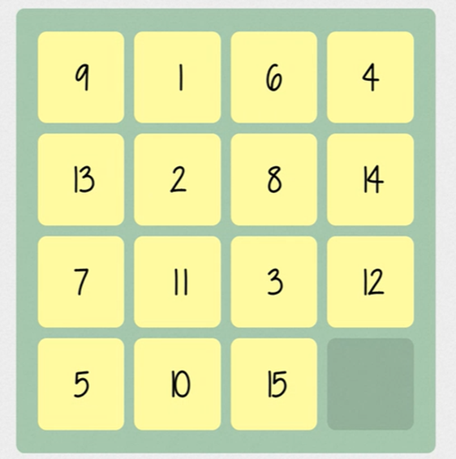 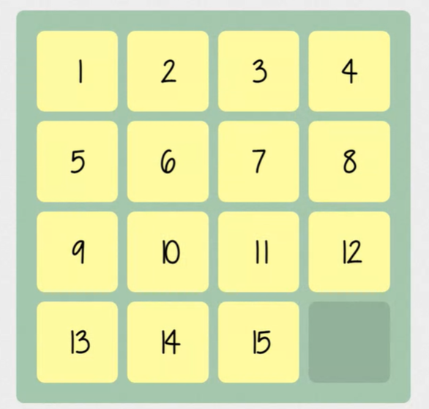

**8 -Puzzle**

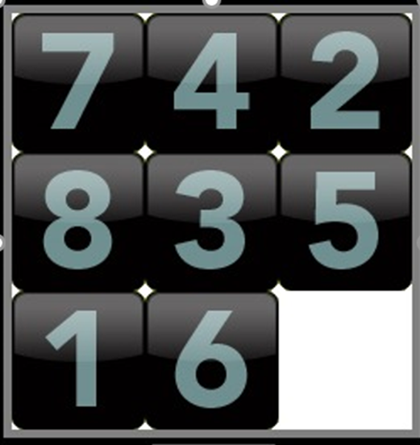 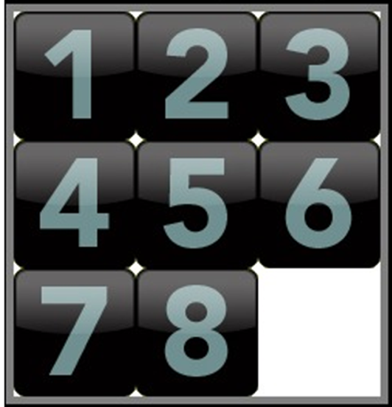

**Conclusion and Future Work :**

* **Design a simple functional game on 8 Puzzle . With Options to Randomize the board and a output window which will show the continuous number of Outputs will be displayed .**
* **Read More Research Papers on Effective Algorithms for 15 Puzzle.( Mostly on Heuristic Search Techniques.)**
* **And finally Create a Recommendation System which will suggest which type of Algorithm will be useful in which case so that use could get a pre-hand idea on the Algorithm part .**

**References :**

[**https://www.researchgate.net/publication/259694537_Experimental_Comparison_of_Uninformed_and_Heuristic_AI_Algorithms_for_N_Puzzle_Solution**](https://www.researchgate.net/publication/259694537_Experimental_Comparison_of_Uninformed_and_Heuristic_AI_Algorithms_for_N_Puzzle_Solution)**.**

[**https://www.geeksforgeeks.org/a-search-algorithm**](https://www.geeksforgeeks.org/a-search-algorithm)**.**

[**https://www.geeksforgeeks.org/a-search-algorithm**](https://www.geeksforgeeks.org/a-search-algorithm)**.**